The Laybrinth

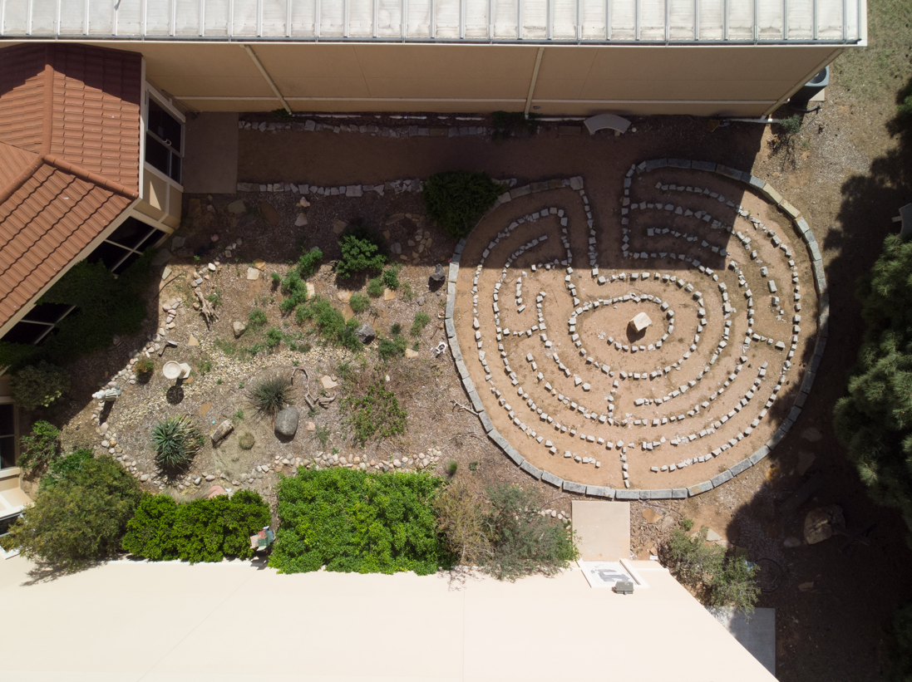

What Is A Labyrinth?
Labyrinths are pathways shaped into twisting, turning designs; they have been used as spiritual tools by Christians for at least 1,600 years.
In today’s world, Christians walk labyrinths for prayer, meditation, help finding the quiet Center of their living, to facilitate calm and stillness in a hectic world, to find faithful clarity amidst life’s challenges and opportunities, to listen for God, as a tool for health and wellness, and much more.
An ongoing practice of labyrinth walking is a celebrated discipline for Christians seeking an authentic life of balanced wholeness in which intimate relationship with God is sought and valued.
There is no right way to walk a labyrinth. You only have to enter and follow the path. However, your walk can encompass a variety of attitudes. It may be joyous or somber. It might be thoughtful or prayerful. You may use it as a walking meditation.
When you walk a labyrinth choose your attitude. From time to time choose a different attitude. Make it serious, prayerful, or playful. Play music or sing. Pray out loud. Walk alone and with a crowd. Notice the sky. Listen to the sounds. Most of all, be open to the various ways God can meet you
General guidelines for walking a labyrinth are:
Focus: Pause and wait at the entrance. Become quiet and centered.
Experience: Walk purposefully. Observe the process. When you reach the center, stay there and focus several moments. Leave when it seems appropriate. Be attentive on the way out.
Reflect: After walking the labyrinth reflect back on your experience. Use journaling or drawing to capture your experience.

